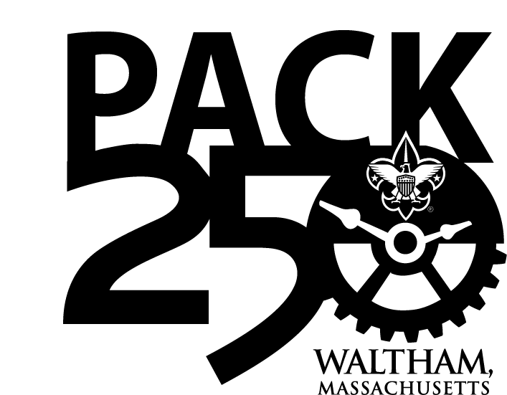

**Campout**

**Packing List**

|  |  |
| --- | --- |
| **Equipment** | |
| ¨ | Backpack (a large sports equipment bag or duffel bag will also work) |
| ¨ | Sleeping Bag |
| ¨ | Tent (with ground cloth) If not sleeping in the cabin |
| ¨ | Closed-Cell Foam Sleeping Pad |
| ¨ | 2 One-Quart Water Bottles (filled) |
| ¨ | Flashlight & Extra Batteries |
| ¨ | Soap |
| ¨ | Toothbrush & Toothpaste |
| ¨ | Comb/Brush |
| ¨ | Bug Spray |
| ¨ | Sunscreen |
| ¨ | Small First Aid Kit (optional – the pack will have one) |
| ¨ | Camp Chairs or folding chair |
| ¨ | Plastic Plate, Fork and Knife (these can be anything from your kitchen |
| ¨ | Camp Chair or folding chair |

|  |  |
| --- | --- |
| **Clothes** | |
| ¨ | Warm Jacket (it can get cold at night) |
| ¨ | Raincoat |
| ¨ | Wool Sweater, Fleece, or Sweatshirt |
| ¨ | Warm Hat (to wear at night when you sleep) |
| ¨ | Shorts |
| ¨ | Long Pants (bring an extra pair) |
| ¨ | Tee Shirts (including one to sleep in) |
| ¨ | Long Sleeve Shirt |
| ¨ | Socks (bring extras) |
| ¨ | Underwear |
|  | Bathing Suit and Towel (If camping at New England Base Camp) |
| ¨ | Sneakers |
| ¨ | Hiking Boots (nice to have but not required, bring an extra pair of sneakers if you don’t have boots) |

**Tips**

–      Reinforce the principle of the Buddy System with your scout

–       Bring your own drinking cups and plates – think Green

–       **No flip flops or crocs** – they offer no protection for your feet

–       Always pack for one season colder than it is.  Layer your clothes.

–      NO scouts are allowed to have axes at any time, parents leave them at home as well!

–       Pocketknives are permitted only for those scouts that have Whittling Chip Card. Scouts without possession of valid WC and or are in violation of any WC rules will have their pocketknife confiscated by a